Civil war in Liberia

UNSC Resolution: | 1408
Date of adoption: | 6-May-2002
Operative paragraph: | 4
Demand number: | 1408,0411

Sarah-Myriam Martin-Brûlé

Wording of demand

cease military support for armed groups in neighbouring countries, take action to prevent armed individuals and groups from using their territory to prepare and commit attacks on neighbouring countries and refrain from any actions that might contribute to further destablization of the situation on the borders between Guinea, Liberia and Sierra Leone

List of addressees of the demand

Government of Liberia

Short-term compliance

Description of the addressee(s)’ conduct

“7. The Government further noted that Sierra Leone had just successfully held free and fair elections with the full cooperation and participation of RUF, which had since transformed itself into a political party. It further pointed to the absence of any armed hostilities in Sierra Leone for most of 2001 and 2002 as sufficiently indicating that the Government of Liberia harboured no plans to destabilize Sierra Leone or any other State in the subregion.”
(…)
13. For the present report, UNAMSIL reported that it had not observed any indications of the Government of Liberia’s continued support of the Revolutionary United Front Party (RUFP), financially or logistically. This reference to RUFP by UNAMSIL, as the members of the Council are aware, stems from the fact that the RUF rebel group no longer exists in Sierra Leone, having been supplanted by RUFP for the legislative and presidential elections that were held in that country in May 2002.
(…)
16. According to the Government of Liberia, all known ex-RUF members have been expelled from Liberia. About 12,500 Sierra Leonean refugees in Liberia have been repatriated, and 25,000 more are awaiting repatriation with the cooperation of UNHCR and the Government of Sierra Leone.
(…)
17. Independent sources indicated that there was no evidence of the presence of RUF members in Liberia. Some sources however alleged that some RUF members may have been integrated into the security service of Liberia.
(…)
18. The Government of Liberia indicated that the question of financial and military support to RUF was no longer relevant because RUF had been disarmed and was no longer in existence as a fighting force. It had been transformed into a political party and had participated in the Sierra Leonean elections.
(…)
19. The personalities and organizations consulted could not provide any proof of Liberian Government support to RUF.
First report of the Secretary-General pursuant to Security Council resolution 1408 (2002) regarding Liberia, 22 October 2002

Assessment

Short-term compliance
No or marginal compliance (1) | X Medium low compliance (2) | Medium high compliance (3) | Full or almost full compliance (4)

Considerations underlying the assessment

Within the six months after the adoption of the resolution, the government of Liberia complied with aspects of the demand which were of relatively low significance to the achievement of the objectives of the demand, namely ceasing support to RUF yet re-arming the ex-RUF members and keeping close ties with rebel groups in neighbouring countries.

Medium-term compliance

Description of the addressee(s)’ conduct

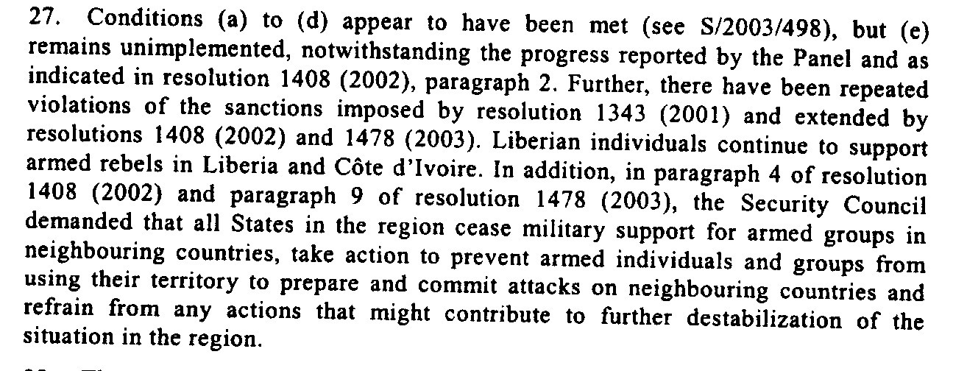
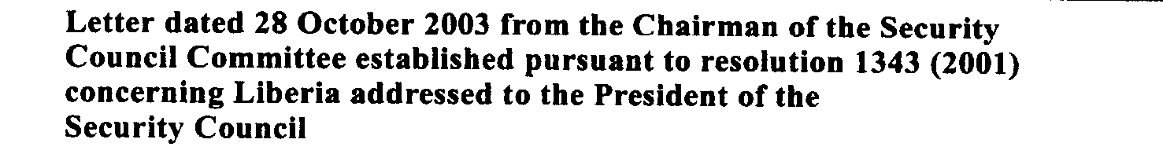

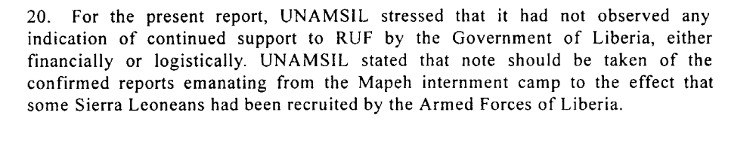
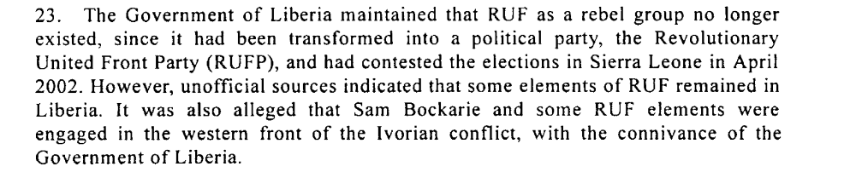

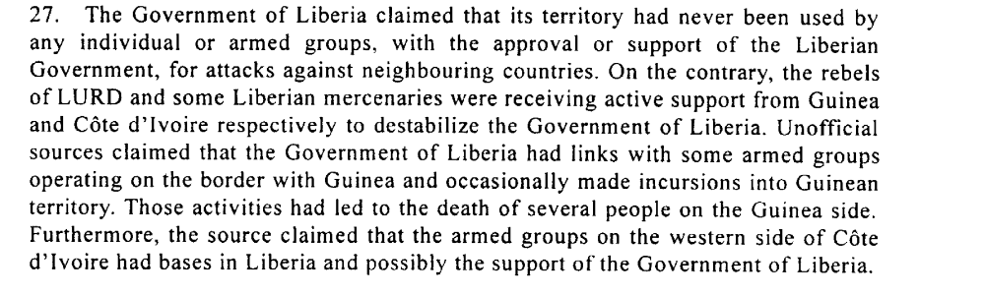
United Nations Security Council. Second Report of the Secretary-General Pursuant to Security Council Resolution 1408 (2002) regarding Liberia, 22 April 2003

“In the Expert Panel Report on Liberia (November 2002), the Panel stressed the volatility of the entire West Africa region, and the continued proliferation of bandits, rebel groups, mercenaries, uncontrolled police and militias wreaking havoc on the region. The panel received numerous accounts of groups of mercenaries from Sierra Leone, Liberia, Guinea, the Gambia, Ghana and Burkina Faso offering their services to the various warring groups in the region, serving to the highest bidder. The Budumburam refugee camp in Ghana, which houses tens of thousands of Liberians, was recently raided by the Ghanaian government on suspicion of mercenary recruitment, a charge that turned out to be true6. One mercenary reported that he had been offered US$10,000 by Liberia to fight against the British troops in Sierra Leone.”
Global Witness Report. 2003. “The Usual Suspects Liberia’s Weapons and Mercenaries in Côte d’Ivoire and Sierra Leone : Why it’s Still Possible, How it Works and How to Break the Trend” . 31 March.
http://www.reliefweb.int/rw/RWFiles2003.nsf/FilesByRWDocUNIDFileName/ACOS-64CNHR-gw-lbr-31mar.pdf/$File/gw-lbr-31mar.pdf

“President Taylor increasingly employs rebel troops in western Côte d’Ivoire, which he treats as a second front against the Liberians United for Reconciliation and Democracy
(LURD) insurgency that threatens his rule. Ivorian President Laurent Gbagbo is paying and arming just about anyone to balance Taylor’s support for his foes. His largesse enabled the formation of a new LURD faction, which calls itself the Movement for
Democracy in Liberia (MODEL). It is advancing against Taylor at the same time as it challenges, for primacy in the rebellion, both the LURD leadership based in Guinea and its military wing fighting on Liberian soil.
ICG. 2003. Tackling Liberia: the Eye of the Regional Storm. 30 April.
Africa Report No.62 Freetown/Brussels
http://www.crisisgroup.org/library/documents/report_archive/A400960_30042003.pdf

“The NTGL’s continued failure to function effectively has significant ramifications for the country’s long-term reconstruction prospects, as well as for the security of Liberia and its neighbours.
(…)
“the Expert Panel Report on Liberia (November 2002), the Panel stressed the volatility of the entire West Africa region, and the continued proliferation of bandits, rebel groups, mercenaries, uncontrolled police and militias wreaking havoc on the region.The panel received numerous accounts of groups of mercenaries from Sierra Leone, Liberia, Guinea, the Gambia, Ghana and Burkina Faso offering their services to the various warring groups in the region, serving to the highest bidder.The Budumburam refugee camp in Ghana, which houses tens of thousands of Liberians, was recently raided by the Ghanaian government on suspicion of mercenary recruitment, a charge that turned out to be true6. One mercenary reported that he had been offered US$10,000 by Liberia to fight against the British troops in Sierra Leone.”
Global Witness Report. 2003. “The Usual Suspects Liberia’s Weapons and Mercenaries in Côte d’Ivoire and Sierra Leone : Why it’s Still Possible, How it Works and How to Break the Trend” . 31 March.
http://www.reliefweb.int/rw/RWFiles2003.nsf/FilesByRWDocUNIDFileName/ACOS-64CNHR-gw-lbr-31mar.pdf/$File/gw-lbr-31mar.pdf

Assessment

Medium-term compliance
X No or marginal compliance (1) | Medium low compliance (2) | Medium high compliance (3) | Full or almost full compliance (4)

Considerations underlying the assessment
Within the two years after the adoption of the resolution, the government of Liberia complied with no or almost no aspects of the demand of any significance to the achievement of the overall objective of the demand (hiring mercenaries, re-arming ex-RUF fighters, fomenting rebellion in neighbouring countries).

Depth of demand

Assessment

Level of depth of demand
Low depth of demand (1) | Medium depth of demand (2) | X High depth of demand (3)

Considerations underlying the assessment

Level of confidence about coding decisions

Level of confidence about coding decision
Extremely high | X High | Moderate

Comments to IPI (if any)

